The Takeaway:
A Summary of Learning From OLTD 503

Derek Cockram

Vancouver Island University

OLTD 503

Abstract
My paper is a summary of the learning I will take away from my studies in OLTD 503. It is my reflection on the content of the course and my first experience as an online facilitator.

The Takeaway:
A Summary of Learning From OLTD 503

Looking Back
A little over a month ago I created the OLTD 503 folder on my one drive and got to work writing about my teaching philosophy and its relationship to my teaching practice. It was the second time I had done such an assignment. The first time had been at the conclusion of my Bachelors of Education degree a decade earlier. I reflected then that my naivety is setting out into my profession was almost comical in retrospect. However, I have a feeling, despite the fact that I have been seasoned with a little more maturity, or perhaps cynicism, a decade from now I will look back on this writing here and think “what a fool”.
I sincerely hope I do. I sincerely hope that I am still the person who takes the time to reflect on where I came from and the path that I have taken to get to where I am. I hope I don’t grow complacent. I hope that in the intervening years I continue to improve as an educator- both online and in face to face settings. I hope that with that growth comes greater skill, knowledge and wisdom. After all, aren’t these the gifts that education promises? Isn’t that why we study? Isn’t that why we teach? I hope I always look back with a hint of dissatisfaction for my former self. I think it’s a sign of evolution.

Understanding the Role of Theory
In my initial work for the course I wrote about the gap between my philosophy for online communication and my actual experience of it. My first essay focused on the role the ideal plays in formulating educational theory through a kind of backward design. As OLTD 503 is billed as a course about online communication, the focus on theory seemed a little strange to me. We already covered a lot of educational theory in 501 and 502. I expected OLTD 503 to be largely about how to use online communication tools, and it certainly was that, but perhaps of equal value was how much I learned about communities of inquiry through this course.
I encountered the Community of Inquiry framework for the first time in OLTD 501. I thought I understood it when I read about it, albeit in a vague sort of way. Any group of people engaged in a shared study of a topic where they communicate with one another to share knowledge to create and confirm meaning constitutes a community of inquiry. As it pertains to education it is a community that is established or guided by an instructor.
The community of inquiry framework posits that successful collaborative constructivist learning is achieved online through the interplay of three factors: the teaching presence; the cognitive presence; and the social presence.
Creating a successful teaching presence requires not only laying out the objectives and academic expectations for the course, it requires the instructor to build a personal connection with the students so that they feel an attachment. The cognitive presence refers to the student’s engagement with the material of their studies. Students often have different attitudes towards learning and online instructors must design courses so that they appeal to both deep and surface learners (Kear, K. 2010). Social presence refers to the students’ belief that they and their classmates can project their identities online and interact with others. This is done both synchronously and asynchronously through a plethora of means as witnessed throughout OLTD 503. The COI framework suggests that when all three presences are adequately addressed, online learning will be successful.
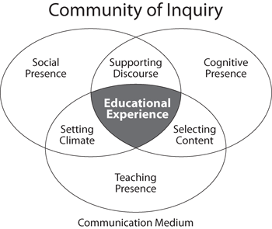

As I said, I understood the theory of COI at the outset of the course, but until OLTD 503 I have never actually understood what a community of inquiry actually looked like. I am a little embarrassed to admit I didn’t recognize it right away.

Recognizing Theory in Practice
For all my supposed knowledge of COI and modern education practices, about how the “sage on the stage” had to be replaced by the “guide on the side”, when I finally took a course where the instructor wasn’t spoon feeding me information I was confused. I have never taken a course before where I had less interaction with the instructor. I found myself complaining about it one day to my wife.
“What do you mean she doesn’t teach?” she wanted to know.
So I explained to her that our instructor had brought us all together on the first day and introduced herself, set up her expectations for the class and broken our cohort into groups. She then assigned each group a topic to research and given us guidelines on how to present our topic to the rest of the cohort. From then on we were responsible for learning about our selected topics and teaching the other members of the cohort.
“Well are you learning?”
Well yes- I had to admit I was learning a lot. The whole experience of teaching and working collaboratively online was new to me and I found it exceedingly challenging and rewarding. Plus being part of a team where we were relying on one another made me more accountable for my learning. A behaviour that I had already noticed in myself with regard to physical fitness- I always run harder when playing soccer than I do running on my own.
On top of that, many of the other groups in the cohort introduced me to countless tools for communicating online and organizing my work. All the groups in the cohort did an excellent job of conveying the key information from the various chapters and included articles and video resources that complimented Kear’s book. The discussion forum, if not always lively, provided us with an opportunity to discuss our ideas, opinions and interpretations. This was particularly valuable as our cohort has a rich diversity of experience and knowledge. Finally, the presentations of each group were varied and unique. My feeling is that no one individual could have produced the variety of activities and resources in so short a time.
“Well if she’s responsible for making all that happen…” my wife didn’t bother finishing.
So although I didn’t necessarily see it right away, all of the ingredients for a successful community of inquiry were present in OLTD 503. Understanding how a community of inquiry functions in practice will be my biggest takeaway from the course, but it is by no means the only thing I learned. Here are a few of the other lessons I will take into my future practice.

Be Reasonable
At the outset of the course, when I was asked to select an image that reflected my experience with online communication, I suggested the carnival game Wack-a-Mole might be the most appropriate, but perhaps this image doesn’t go far enough. Perhaps Hercules fighting the Hydra would be better, and not just because I like casting myself in the role of a muscled Greek demi-god. Like the Hydra’s rapidly multiplying heads, every online interaction seems to lead to more and more interactions. From emails and texts to messenger messages, Facebook updates, Google hangouts, skype calls, forum posts, each one might represent a head of the beast demanding your time and attention. Just staying on top of regular correspondence can quickly become a full time job.
I was both relieved and delighted to see a chapter of Kear’s book devoted to exactly this problem: information overload. I was relieved because this was a sufficiently common problem that it merited inclusion in a guide for online educators. Up until I saw the topic on the OLTD 503 syllabus, I was rather anxious that my inability to keep up with the torrent of information was the result of my being more of a “digital interloper” than a “digital native”. It was comforting to know that this is in fact a common problem.
I was delighted because she included some research-backed strategies for online educators who want to avoid overloading their students. From nesting threads in forums to providing tools to filter information and tag relevant posts to providing instruction with bookmarking applications, Kear makes the unmanageable more comprehensible.
Perhaps just as importantly, within the cohort we had a rich discussion on the topic and I was able to learn from my colleagues’ best practices. Whether communicating with students, parents or other professionals, I feel I am better able to set reasonable limits on my and their expectations with regard to online communication and education. I realize that these are best established at the outset of the course. This brings me to my next learning.

Plan Ahead
Whether setting up expectations at the beginning of a course, an important aspect of establishing a teaching presence, or establishing a schedule to collaborate online, online teaching requires more advance preparation than face to face instruction. Articles must be curated. Applications must be tried and tested. Audio and video must be recorded. Due to the complex nature of coordinating communication there is little opportunity for improvisation or seizing upon “teachable moments” that so often occur in the classroom- although improvisation is frequently required when the best laid plans go awry.
In the course of our planning our seminar presentation, we learned a great deal about the difficulty of coordinating multiple visions in the planning process. Collaboration requires frequent negotiation and it is difficult to negotiate in a group online. As a result our seminar week became a potpourri of online communication ideas. It might have been slightly overwhelming to our cohort, but it was also very original which brings me to my final learning.

Be Creative
I am creative. I haven’t stopped being creative just because I eventually decided to , yaaaawn!, write about what I learned in OLTD 503 rather than prepare a short film, a website, a slideshow or interpret the course through a modern dance.
Why is it that we always associate the arts with creativity? Mathematicians are creative. Computer software engineers are creative. Accountants- well… mathematicians and computer software designers are creative. When people tell people to be creative it usually means they are expecting something colourful and lively- think finger painting or plasticine or when it comes to online teaching and learning perhaps Flash animation.
I understand that part of the appeal of online learning is that it gives students increasing opportunities to be creative and certainly course planning and design demand creativity from instructors. I am creative in my face to face teaching and I regularly create games and projects to help students consolidate their knowledge. I even throw in the occasional magic trick to stir their curiosity or a little song and dance to keep everyone from growing overly serious and self-conscious. I am creative in my classroom because I know it is important for engaging students and I am creative because I am confident that I can be. I do not feel the same way about learning and teaching online.
While I recognize the importance of “being creative” and encouraging creativity in my students, teaching online requires a different set of tools or “digital literacies” in order to be creative. Consider Betham and Sharpe’s Model for building digital literacies:
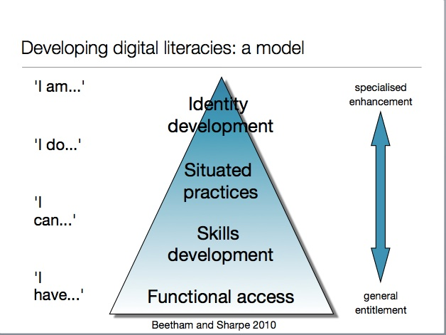
I still feel like I am near the bottom of the pyramid. I am still building my skills with different applications. I am still learning strategies to promote student engagement and stay organized. OLTD 503 has been tremendously helpful in this regard. From introducing me to applications such as Socrative, Showme, Mindmeister and the Google suite to reassuring me that “Information Overload” is a common enough problem that online education experts feel the need to write chapters on how to avoid it, I feel like I am making steady progress towards my goal of becoming an online educator.
This is not an apology for failing to present the summary of my learning as a more engaging way. I have spent enough time with the members of this cohort to know that there are going to be some amazingly creative presentations, but that is not me. When it comes to sharing my thinking or my ideas, it’s hard to beat a clear font on a nice white page. Left to right, top to bottom- sweet lucid prose. That’s what I like and that’s who I am which brings me to my final learning.
Be Genuine

Whether you are face to face or online, I think it is always important to show your students a little bit of who you are. Whether you want to call it “establishing a strong teacher presence” as a COI robot might or simply call it “building trust”, in my personal experience I have always learned the most from the teachers I knew and liked.
In order to build that relationship I think it is vitally important to be open with people about your strengths and weaknesses, be honest about your likes and dislikes, let your personality shine through everything you do.
This doesn’t mean that I will become friends with my students, only that I won’t pretend to be something that I am not. I think I am getting better at conveying my personality and sense of humour through online communication. As with all things, the more you practice, the better you get.
I am very grateful for the hands on experience OLTD 503 has given me and I look forward to applying the lessons I have learned here in my future career.

References

Beetham, H. & Sharpe, R. (2010) ‘Digital literacies workshop’, Paper presented at the JISC Learning Literacies Workshop, Birmingham quoted in “Learning from the early adopters: developing the Digital Practitioner” by Liz Bennett (2014) Research in Learning Technology Vol. 22

Garrison, D. R., Anderson, T., & Archer, W. (2000). Critical inquiry in a text-based environment: Computer conferencing in higher education model. The Internet and Higher Education, 2(2-3), 87-105.

Kear, Karen (2010) Online and Social Networking Communities: A Best Practice Guide for Online Educators. New York: Routledge

