The Lure of the Labyrinth: An Irresistible Math Adventure

Derek Cockram

OLTD 508: Mobile Learning and Gaming

A trip to the local pet food store goes terribly awry. Beloved pet, Mortimer, left tied up outside the store is abducted by a shadowy figure. You set off in pursuit and soon find yourself in the vast underworld of Tasti-Pet Food Corp. A world filled with hideous creatures and challenging mathematical problems. You’re only ally is a fairy who furnishes you with a disguise and offers a bit of advice. Do your best. You soon find a place as an employee in the Corporation and get to work solving puzzles in order to free the animals that the monsters have imprisoned underground, but will you ever find you own beloved Mortimer?
There is a lot to like about Lure of the Labyrinth. Designed with 6th to 8th grade students in mind, it offers a profoundly compelling storyline, engrossing visuals and just the right level of challenge for its target audience. Although it is a stand-alone game, students are able to save their progress through the maze and communicate with their teammates using an online chat. It runs on PC and doesn’t place undue stress on school bandwidth. Best of all, it is absolutely free and teachers are able to extract data on student progress to assess both their engagement and their learning.
Using James Gee’s game designer principles to engage, it is easy to see what make the Lure of the Labyrinth so alluring. First, the game empowers learners by providing identity and encouraging manipulation.
One of the most difficult problems I have had teaching math to Grade 6/7 students over the years has been finding ways to motivate them to learn the material. At the onset of adolescence, some students will no longer do things simply because they have been told they should. They want to know why they have to learn it. What can they do with it? The narrative of Lure of the Labyrinth provides answers to these questions. More often than not it will prevent them from ever being asked.
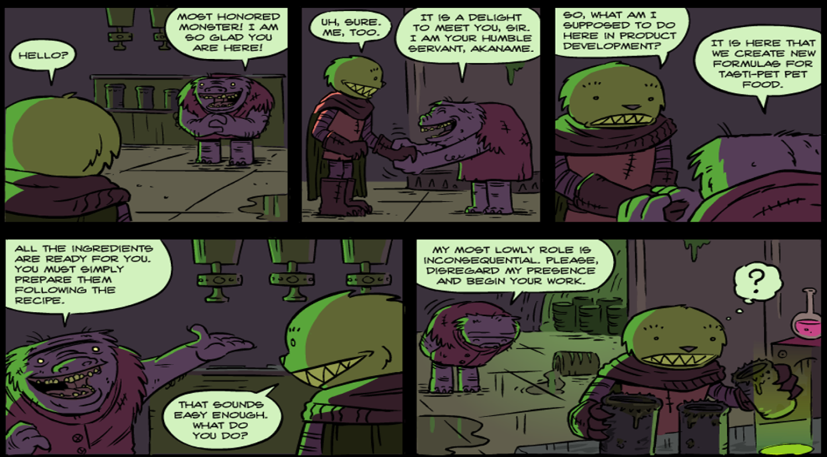
The narrative is advanced through a series of comics throughout the story.

From the opening of the game when you select what type of pet you want, and the colour of your disguise, your experience becomes personalized and tailored to your own tastes. As new challenges open up and you explore further, you have increasing control over what you want to do next.
The game also allows for some customization as players may choose to focus their efforts on solving puzzles, freeing animals or making money and buying things in the company store or any mixture of these three. In addition there are a number of “easter eggs” throughout the game. All of these things helps students to embody their character more which in turn makes them feel more empowered and engaged.
Second, the game combines a number of techniques of Problem based learning. Every puzzle in the game exists in three forms of varying degrees of difficulty. Each of these are sequenced from easiest to most difficult. And each one relies on the mastery of the one before it, but cannot be solved with the same strategy that the previous puzzle used. These features demonstrate two important principles of problem based learning namely: sequencing and the cycle of expertise. Just as students think they have mastered a puzzle, it is subtly altered or a new wrinkle is thrown in which forces them to adapt their thinking and re-evaluate their strategy. Often this initially produces failure which adds another aspect of truly engaging games, pleasant frustration. That feeling that you are capable of achieving some aim, but that it lies at the very limit of your abilities.
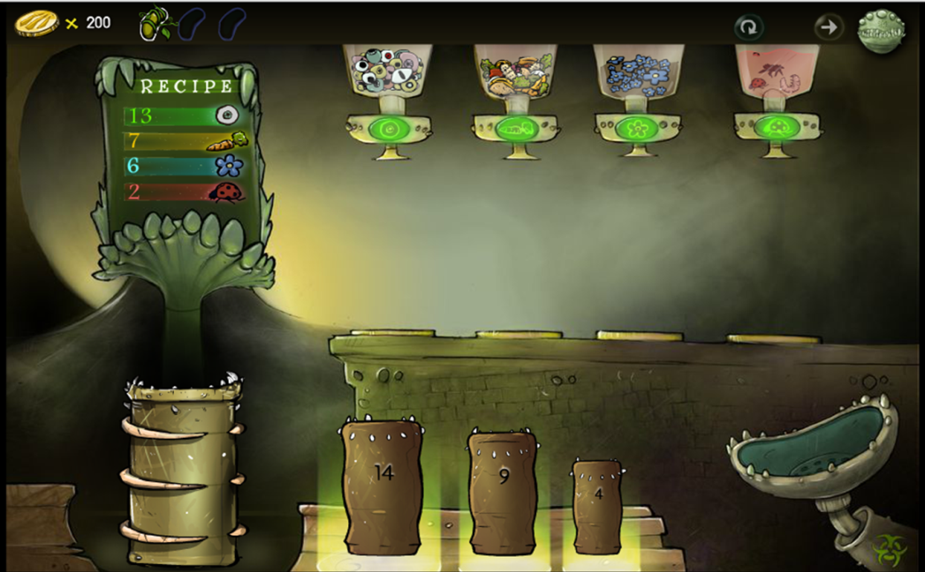
The first level of the testing lab requires alegebra. Subsequent levels require students to use ratios and determine equvalant fractions.

Overall the game is very intuitive. Menu screens are clear and easy to navigate between. Most students, even those with little to no game experience will quickly be able to master control of their character. Initially, there are blunt hints to guide player’s actions and the game introduces complexity gradually revealing more and more areas of the Labyrinth depending on the number of puzzles solved.
However, there is very little instruction in the puzzles themselves. This is done deliberately to promote trial and error. Students often start a new puzzle with no idea what to do. They click at a point on the screen and see what happens. That is another important benefit of the game: it provides students with direct and immediate feedback. This works, that doesn’t. Using this feedback students begin to make inferences about what might be expected of them, but for those “perfectionists” gamers out there (my son is one) this maybe a hurdle to overcome. Regrettably, a number of students in my class would sooner do nothing at all than risk making a mistake in math class.
Overall, as a teaching tool the game is an excellent resource for a class. Puzzles reinforce concepts of number and operations as well as number lines; they cover multiples, fractions, ratio, algebraic expressions, even perimeter, area and, if you include the maps, the Cartesian coordinate grid. The majority of these items are expected learning outcomes for Grade 6 students in BC. I would introduce this game to students in Grade 6 as early as the beginning of the second term. However, the more advanced puzzles would still be challenging for many Grade 8 students.
Students will learn through playing for as James Gee explains in good games, “The learning environment must encourage active and critical learning. They actually think, act, experience consequences and pursue goals in a variable game environment”. Furthermore students will not be dissuaded from these goals for in games such as Lure of the Labyrinth “Learners get lots of practice in a context where the practice is not boring (i.e. in a virtual world that is compelling to learners on their own terms and where the learners experience ongoing success)” (2003). Ongoing success is an important factor in keeping students engaged and Lure of the Labyrinth accomplishes this by giving players routine rewards in the form of money and unpredictable bonus awards by occasionally allowing them to free imprisoned pets.
I cannot recommend this game enough. I am confident that if every Grade 6 and 7 student in the province started playing the game tomorrow there would be a perceptible improvement in our learning outcomes in math by the year. Students are going to drawn in by the narrative, but they will keep playing and keep practicing their math skills because their learning has become an engaging game.

References:
Gee, James Paul. Principles on Gaming, Retrieved on March 19, 2016 from https://youtu.be/4aQAgAjTozk
Gee, James Paul. What Video Games Have to Teach Us about Learning and Literacy. New York: Palgrave Macmillan, 2003.

