Remaking Riverside:
A Proposal for Creating a Blended Learning School
OLTD 511
Derek Cockram

The School:
Riverside Elementary is a small school in south Burnaby. It is an inner-city school, where many of the students come from challenging socioeconomic backgrounds. It has a declining enrolment and a high ELL population. FSA results and school board audits indicate that a disproportionate number of students are functioning below grade level in reading, writing and mathematics. The school board has attempted numerous interventions- increased ELL and learning support, changed administrators, introduced strong start programs, but to date there have been no discernible improvement in student learning outcomes. This has produced a palpable culture of cynicism among students, parents and teachers.
The problem that we are attempting to address is two-fold. First, we must find a way to increase students’ engagement with their learning. Increasing student motivation towards their learning is key to meeting the second objective which is to improve student learning outcomes.

The Plan:
The challenging circumstance that Riverside finds itself in makes it an ideal candidate for a new blended learning program. Blended Learning is any formal education program in which a student learns at least in part through online learning, with some element of student control over time, place, path, and/ or pace (Horn).
Blended learning can address the fundamental problem of student motivation that is plaguing Riverside by allowing students to have more autonomy over their learning. As Drennan, Kennedy, and Pisarki reported “students who believe they have control over their learning enjoy higher levels of course satisfaction” (2005). Students at Riverside will be given more choice over what and when they learn. This is more popularly known as student-centered learning. As Horn (2014) explains, “Student-centered learning is essentially the combination of two related ideas: personalized learning (what some call “individualized learning”) and competency-based learning (also called “mastery-based learning,” “mastery learning,” “proficiency-based learning,” or sometimes “standards-based learning”).

The Program:
Students who attend Riverside will be given the chance to learn at their own rate and control the width and depth of their learning within broadly established guidelines designed by the faculty. Rather than pass through grades according to their ages, students will be assigned homerooms in one of three mixed-aged divisions: Primary, Junior or Intermediate. This decision was made on the basis of Pratt’s meta-study of research into multiage classrooms which determined “multiage grouping has no consistent effect on academic achievement. Multiage grouping does, however, tend to be associated with better self-concept and attitude toward school.” The multiage classroom discourages competition between students “because they are all on different levels and have different expectations set for themselves” (Aina) and is particularly beneficial for children whose development differs from the norm (Pratt). As schools like Riverside begin to embrace personalized learning the rationale for segregation based upon students’ ages is undermined. The program at Riverside will reflect this new reality.
Within their divisions, students will have a variety of units which they will be able to complete with the assistance of their teachers. The following is a basic outline of the units required to complete Elementary school. In addition, students will need to complete a variety of “Inquiry Projects” on special topics of their own choosing.
Primary  K-2 | Junior  3-5 | Intermediate  6-7
Riverside Elementary Curriculum Framework

Math and Logic
Number | Operations | Problem Solving/ Graphing | Geometry | Fractions and Decimals | Logic | Algebra
Level 1 | Level 1 | Level 1 | Level 1 | Level 1 | Level 1 | Level 1
Level 2 | Level 2 | Level 2 | Level 2 | Level 2 | Level 2 | Level 2
Level 3 | Level 3 | Level 3 | Level 3 | Level 3 | Level 3 | Level 3
Level 4 | Level 4 | Level 4 | Level 4 | Level 4 | Level 4
Level 5 | Level 5

English Language Arts
Early Literacy | Folklore | Mythology | Poetry and Song | Novels | Grammar | Writing
Level 1 | Level 1 | Level 1 | Level 1 | Level 1 | Level 1 | Level 1
Level 2 | Level 2 | Level 2 | Level 2 | Level 2 | Level 2 | Level 2
Level 3 | Level 3 | Level 3 | Level 3 | Level 3 | Level 3 | Level 3
Level 4 | Level 4 | Level 4 | Level 4 | Level 4 | Level 4 | Level 4
Science and Technology
Physical Science | Life Science | Earth and Space | Engineering | Computing
Level 1 | Level 1 | Level 1 | Level 1 | Level 1
Level 2 | Level 2 | Level 2 | Level 2 | Level 2
Level 3 | Level 3 | Level 3 | Level 3 | Level 3
Level 4 | Level 4 | Level 4 | Level 4
History and Geography

Ancient Civilizations | Canadian History | Civics | Canadian Geogrphy | World Geography
Level 1 | Level 1 | Level 1 | Level 1 | Level 1
Level 2 | Level 2 | Level 2 | Level 2 | Level 2
Level 3 | Level 3 | Level 3 | Level 3 | Level 3
Level 4 | Level 4 | Level 4 | Level 4

Visual and Performing Arts
Drawing | Painting | Modeling | Handwork | Drama | Dance
Level 1 | Level 1 | Level 1 | Level 1 | Level 1 | Level 1
Level 2 | Level 2 | Level 2 | Level 2 | Level 2 | Level 2
Level 3 | Level 3 | Level 3 | Level 3 | Level 3 | Level 3
Level 4 | Level 4 | Level 4 | Level 4

This curriculum framework should serve as a guideline for the teachers who will be charged with developing the scope and sequence of materials for competency-based courses at Riverside. The key element of the proposed changes to the curriculum is that students should be allowed to progress through courses at their own rate. To ensure that students have an adequate breadth of learning, they will be required to complete all of the courses in their division before advancing to the next division. For example, a devoted reader might complete the first three units of Early Literacy in her first two years of schooling, but she wouldn’t be able to begin level 4 until she had also completed the entire required math. Reporting to parents will be continuous as all feedback to the students will be shared with their parents.

The Week:
Students who attend Riverside Elementary will experience a variety of different types of blended learning formats depending on their division. For a typical junior, each morning would begin with a station rotation in math class where students could alternate between working with their teacher, face to face, and spending time practising on either IXL Math or Khan Academy. A similar model would be followed for language arts where some students would work on their grammar and reading comprehension using online applications like those found on ELA English. Alternatively, they may use the computers to journal about their learning on Kidblog. At other times they will be working in small groups with their teacher studying poetry or engaged in discussion about a novel they are reading.
Students working on their own or in small groups not directly supervised by the teacher can get additional help from a teaching assistant assigned to their classroom during station rotation blocks.
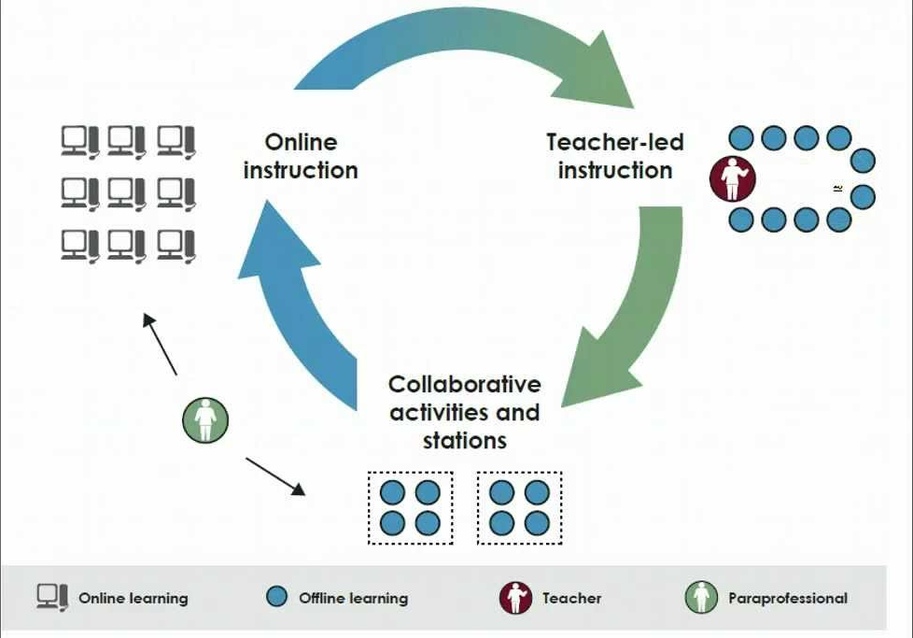
Image taken from http://mrsschwappah.weebly.com/
During other periods, use of computers may be limited or virtually non-existent. Classes in Art, Music and even History and Geography may be indistinguishable from those taking place in other schools in the district. Inquiry projects however, offer students another opportunity to direct their own learning. Finally, the language program at Riverside would again make use of the computers. Allowing students to choose a second or third language to study using a popular program such as Duolingo or Rosetta Stone. This is known a version of the a la carte model of blended learning.
Finally, a schedule of a typical week for a Junior student might look something like this:
The Teachers:
Currently the Burnaby school district does not recognize the specialized expertise of technologically savvy educators. This is regrettable as not all (or even most) teachers in the district are ready to step into teaching in the radically different environment I am proposing. For this reason, I would like the district and the union to agree to create a TechEducator designation the requirements of which can be determined through joint negotiations between the district and the union.
This is merely an acknowledgement that teaching with computers using online applications requires additional training, knowledge and a specialized skill-set that currently lies beyond the scope of teacher education programs in British Columbia- much like the specialization of learning support teachers, ELL teachers and librarians. However, unlike these other specializations, in establishing this designation, the district should recognize the abilities of teachers who can already demonstrate a proficiency incorporating technology. Who better to foster and encourage independent learners than teachers who are themselves self-directed?
The role of teachers at Riverside elementary will be significantly different than teachers at other schools. Teachers will have less marking to do as much of the feedback to students will be handled by the applications themselves. However, the expectation is that by passing on some of the drudgery of marking homework to computers, teachers will have more time to develop interesting and engaging hands on activities. Teachers will also have additional duties-periodically reviewing course materials and updating course content.
In other respects there is a lot that will be familiar to teachers. They will continue to coach and advise their students, make suggestions and recommendations and provide some feedback and answer questions. They will have to monitor the progress of students in their courses and communicate expectations to students and their parents. However, it is hoped that the amount of time teachers spend in conversation with students will increase as a result of the blended learning environment. It should be possible for teachers to work with students in smaller, more manageable and more intimate groups than ever before. This will give them more time to devote to the social and creative development of the children in their care.
Teaching assistants will also have an important role to play. They will be responsible for supervising students working in small groups and on the computers.
Finally, the school librarian will have a key role to play both in supervising children who are working in the school’s “maker space”- an area devoted to students working with hands on activities- and in supporting teachers by finding and developing resources for lessons.
The Task:
The question is, assuming that the district wants to proceed, transforming Riverside into a blended learning environment, what is necessary to achieve the transformation? According to Michael Horn, this is the work of a “heavy weight team”. Members of a heavy weight team “bring their functional expertise with them as they join the heavyweight team, but their mindset must never be to represent the interests of their departments during the team's deliberations. Rather, they think of themselves as having collective responsibility to figure out a better way to knit things together to meet the overall project's goals.”
Members of the team elected to transform Riverside would include district principals of instruction to help parse and splice the BC curriculum’s learning outcomes into the school’s courses. The heads of committees would also be asked to join. Members of the district technology team, including the administration of Burnaby online, would be needed to make logistical recommendations. And the entire project would be overseen by Riverside’s principal.
At minimum the school’s must decrease the current ratio of students to computers from 10:1 down to 3:1 as students are expected to spend approximate 1/3 of their time online. By installing lockers, the school could encourage students to bring their own devices from home- a source of potential savings for the district- both at the outset and in maintenance costs over time. In addition, licences for some of the software must be purchased including IXL Math as well as Kidblog. The following a rough estimate of expenses required to outfit the school and maintain the program in subsequent years.

Start Up Expenses:
New Computers |  |  | $24,000
Desks and Chairs |  |  | $7,000
Renovations and upgrades to the school |  |  | $13,000
Ongoing Yearly Expenses  Software |  |  | $3,360
Additional Staff
Network Administrator |  |  | $66,000
Teaching Assistant |  |  | $29,782

The overall cost of establishing a blended could be cost neutral if the school was ready to take the step of eliminating small group ELL classes and instead designate one homeroom from each of the three divisions as ELL. They would then have their entire program modified to reflect their lack of English language skills. This model could prove superior to the existing model and present the district with enough savings to offset the cost of a full time network administrator and teaching assistant. Similarly, cost savings could be found by replacing existing EA positions with TA positions going forward.
A typical classroom layout at Riverside might look something like this: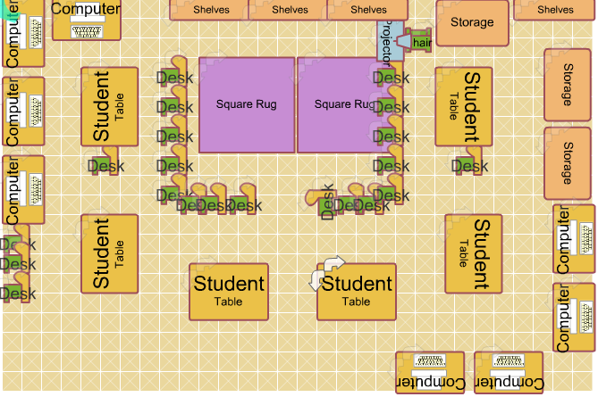
Image taken from http://mrsschwappah.weebly.com/

The Result:
Riverside Elementary is an ideal candidate for introducing a blended learning program. First, parents are frustrated with the status quo and open to the idea of experimentation. Second, the school’s declining enrollment is actually an asset as it has more space than it currently needs. It currently has approximately 250 students in a space designed for close to 350. This means that there is sufficient room for growth and a successful blended learning program will be able to draw student from beyond the immediate catchment, even beyond the district. If blended learning is implemented properly, Riverside may become a “destination school” for parents desiring a forward thinking education for their sons or daughters. However in order for Riverside to reach its full potential a number of changes will need to be implemented to improve the culture within the school.
Here are just a few initiatives that could go a long way to building a more positive community.
Teachers | Students
- Regular collaboration to ensure best practices are shared | - Contribute to a “culture of caring” that values respect for others
- “global” view of the school. Teachers are responsible for the development of all students | - Develop increased independence
- Continuous communication with students and their parents | - Participate in student leadership and other extra-curricular opportunities
- Regular celebration of learning assemblies that allow students to showcase their achievements | - Engage in peer tutoring and collaboration
- Dedication to providing extra-curricular enrichment opportunities | - Consistently meet or exceed behavioural expectations

Given that the district has already tried a number of unsuccessful initiatives to reform the school, it is clear that Riverside requires a more comprehensive reimagining. Transforming the school into a blended learning environment is a bold initiative that has produced positive results in countless schools like Riverside throughout the United States. I feel that there is nothing to be lost and everything to be gained by blending. I hope you agree.

References:
Aina, Olaiya E. “Maximizing Learning in Early Childhood Multiage Classrooms: Child, Teacher, and Parent Perceptions” Early Childhood Education Journal. June 2001, Volume 28, Issue 4, pp 219-224
Drennan, J., Kennedy, J., & Pisarki, A. (2005). Factors affecting student attitudes toward flexible online learning in management education. Journal of Educational Research, 98(6), 331-338
Horn, Michael B.; Staker, Heather (2014-10-15). Blended: Using Disruptive Innovation to Improve Schools (p. 34). Wiley. Kindle Edition.

