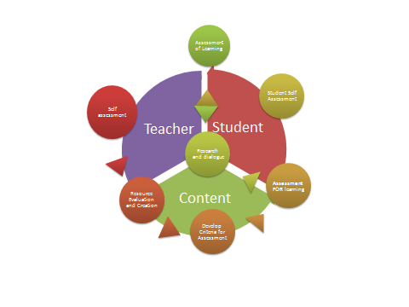
Looking at the different theories of education, I believe I would fall into the constructivist camp. I believe that students are “meaning makers” and that they alone determine the value and relevance of what is being taught and this to a large extent determines the quality and depth of their learning.
Having said that, when it comes to designing a model for learning I believe teachers should lead students through a process of guided discovery. As a result, the learning process begins with the teacher.
The first step for me is looking at the content I would like to teach and evaluating my own understanding of a topic. Next I will familiarize myself with resources both for myself and for my students. I don’t feel like I need to know everything about what I teach, but I should be able to point students towards answers to their questions.
Then before I start to teach, I need to determine what a student with a mastery of the subject knows or is capable of doing. These expectations are going to form the “exceeding” column on my assessment rubric. They are also a tool to demonstrate the value and relevance of what is being taught. They are like a road map showing students where their learning is taking them.
Now it is time to find out where students are. In order to learning to occur, students must be able to assimilate what they are learning to what they already know. Assessment for learning allows the teacher to establish whether or not students have sufficient background knowledge to embark on the selected area of study. It also serves to activate this background knowledge and “prime the pump” for new learning.
This leads us to research and dialogue. This is an opportunity for the student to gain a background in the material and hopefully embrace it as a topic worthy of his or her attention. The depth to which a student delves into a topic will depend largely on the individual student’s interests, but through dialogue with their teachers, students should at least gain an understanding of the significance of the topic being studied. Throughout this process the student must be given an opportunity to evaluate their own learning and pursue aspects of the topic that they find particularly interesting.
Finally the teacher can evaluate the students against the previously established criteria to ensure that the student had retained the salient points of their learning. This will determine whether they are ready to move on to investigate another topic or return to more research and dialogue.
The only thing I feel is missing from this model is the student’s peer group. I believe all aspects of the process I have described depend heavily on the involvement of not one- but of a group of students studying the same material at the same time. Together, they support and share their research and the motivation of each student increases the motivation of every other student.

